8. Scenario: You are a data scientist working for a company that sells products online. You have

been tasked with analyzing the sales data for the past month. The data is stored in a Pandas data

frame.

Question: How would you find the top 5 products that have been sold the most in the past month?

**Code:**

import pandas as pd

df = pd.read_csv(r"C:\Users\vara prasad\Downloads\monthly_sales_data.csv")

df['Order Date'] = pd.to_datetime(df['Order Date'])

recent_sales = df[df['Order Date'] >= pd.Timestamp.today() - pd.Timedelta(days=30)]

product_sales = recent_sales.groupby('Product Name')['Quantity Sold'].sum()

top_5_products = product_sales.sort_values(ascending=False).head(5)

print("Top 5 products sold in the past month:")

print(top_5_products)

**output:**

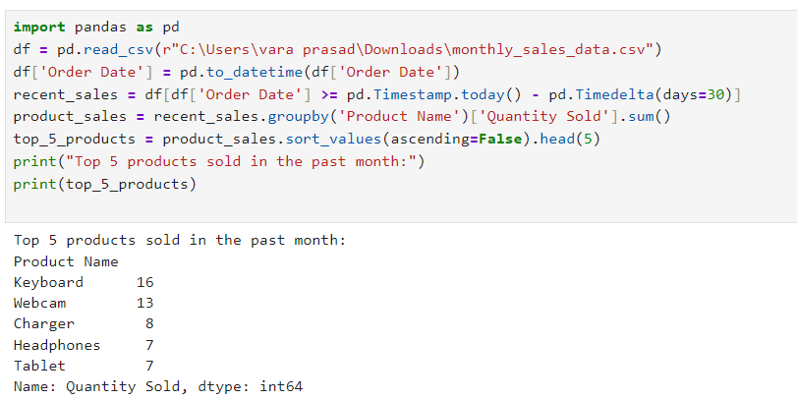

**Dataset:**

|  |  |  |
| --- | --- | --- |
| Order Date | Product Name | Quantity Sold |
| 59:47.3 | Tablet | 6 |
| 59:47.3 | Webcam | 9 |
| 59:47.3 | Keyboard | 10 |
| 59:47.3 | Keyboard | 5 |
| 59:47.3 | Keyboard | 6 |
| 59:47.3 | Laptop | 5 |
| 59:47.3 | Monitor | 7 |
| 59:47.3 | Headphones | 7 |
| 59:47.3 | Webcam | 4 |
| 59:47.3 | Monitor | 1 |
| 59:47.3 | Charger | 5 |
| 59:47.3 | Monitor | 8 |
| 59:47.3 | Headphones | 2 |
| 59:47.3 | Mouse | 6 |
| 59:47.3 | Charger | 1 |
| 59:47.3 | Laptop | 6 |
| 59:47.3 | Charger | 3 |
| 59:47.3 | Tablet | 10 |
| 59:47.3 | Headphones | 4 |
| 59:47.3 | Tablet | 7 |